**SPRINT 3**

**TEAM ID:** PNT2022TMID16894

**PROJECT NAME:** REAL-TIME RIVER WATER QUALITY MONITORING AND CONTROL SYSTEM

**DATE:** 19-11-2022

**SUMMARY:**

In this sprint (3) the following are done:

1. Weather parameters like temperature of the area, description (rain/haze/cloudy etc.) ,etc are given
2. For this open weather api is used.
3. Updation of code is done both in web and mobile app.

**CODE:**

1. **MIT App Inventor:**

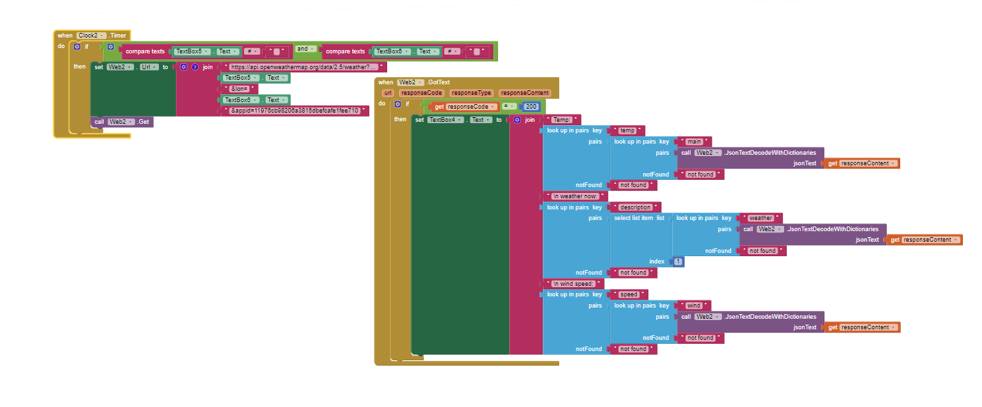

1. **Node Red:**

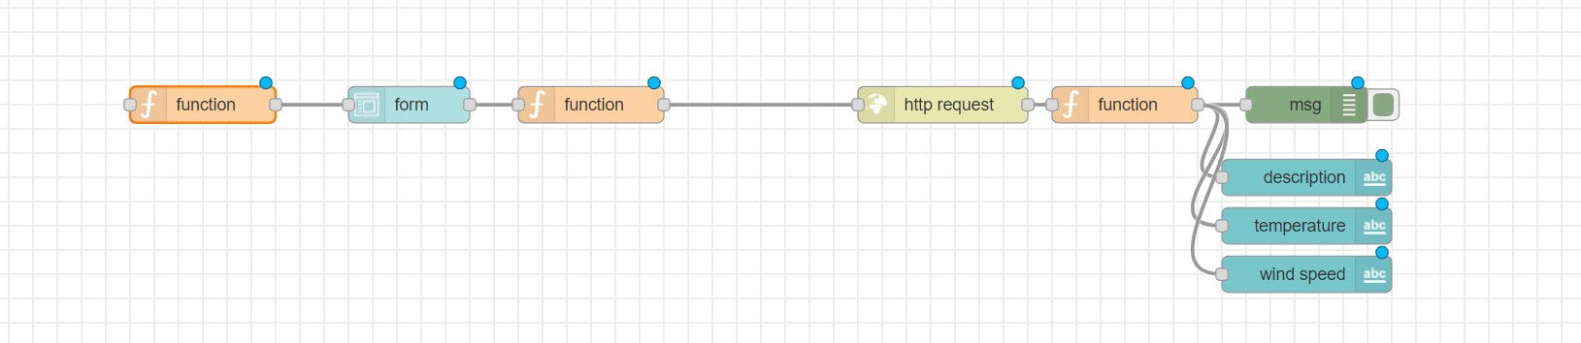

**OUTPUT:**

* 1. **Web app:**

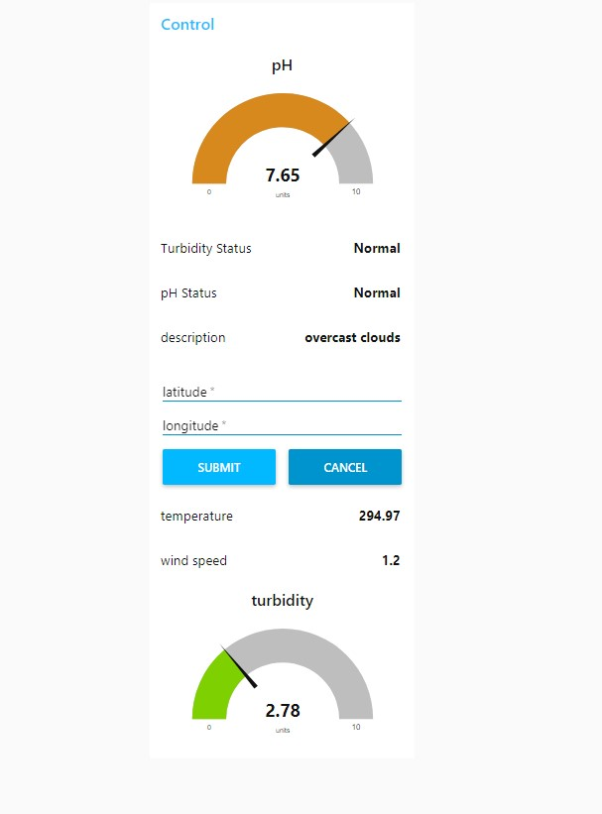

* 1. **Phone App:**

